Методическая разработка к мультфильму “Beauty and the Beast”.
Автор: Зверева О.В.
Предмет: английский язык
Цели:
- Развитие навыков аудирования с целью извлечения главной идеи и затребованной информации;
- Совершенствование навыков использования грамматических времен;
- Активизация лексического материала;
- Формирования навыка пересказа, краткого изложения материала;
- Развитие навыка письменной речи;
- Развитие навыка говорения;
- Воспитание культуры общения в процессе речевого поведения;
- Развитие мышления, памяти и внимания.
Задачи:
- Создать условия для применения знаний в разнообразных учебных ситуациях;
- Развивать умения в основных видах речевой деятельности (чтение, аудирование, говорение);
- Развивать интерес к предмету;
- Развивать способности к слуховой и зрительной дифференциации, непроизвольному запоминанию.
Время реализации: 3 урока

“BEAUTY AND THE BEAST” (1991)
Date: 1991
Country: the USA
Director: Gary Trousdale, Kirk Wise

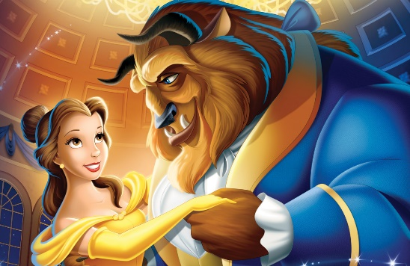

1.Active vocabulary. Make sure you know the words and phrases below. Practice reading them aloud, be ready to do the back-translation.
a castle | enchantress | a petal
spoiled | to apologize | fault
a beggar | a punishment | to stare
in return | a spell | a prisoner
to warn | to conceal | a tray

2.Read the beginning of the cartoon. Fill the gaps with appropriate words. Translate the text.
Once upon a ______ in a far away land a _______ prince lived in a _________ castle. Although he had everything, his ______ desired… the prince was spoiled, ________ and unkind. But then, one winter’s ________ an old beggar woman came to the _________ and offer him a ______ rose in return for __________ from the bitter cold. Repulsed by her nagged ______________ the prince sneered at the ______ and turned the old _________ away. But she warned him not to be deceived by appearances for ________ is found within. And when he dismissed her again, the ____ woman’s ugliness melted away to __________ a beautiful enchantress. The _______ tried to apologize, but it was too ______ for she had seen that there was no _____ in his heart. And as punishment, she ____________ him into a hideous _______ and placed a powerful _______ on the castle and all who _______ there. Ashamed of his monstrous ______ the beast concealed himself _______ his castle with a magic ________ as his only window to the outside ________. The ______ she had offered was truly an enchanted rose, which would _______ until his 21-st year. If he could _________ to love another and earn her love in __________ by the time the last petal _______ then the spell would be ___________.

3.Identify the characters who said the following. Be ready to say under what circumstances the phrases were uttered.
Bell, the Beast, Lumiere, Maurice, Gaston, Chip, Mrs Potts, Le Fou, Doctor.
1. “You must control your temper”.
2. “I thought I’d never see you again”.
3. “I’ve come to collect your father”.
4. “The castle is under attack”.
5. “What’s the matter, beast? Too kind and gentle to fight back?”
6. “By the way, thank you for saving my life”.
7. “He is sick. He may be dying, and he is all alone”.
8. “Belle, why did you go away? Don’t you like us anymore?”
9. “Let me go. Please, don’t hurt me. I’ll do anything.”
10. “Please, don’t leave me. I love you.”
11. “You are the greatest hunter in the whole world.”
12. “How can I read it? There is no picture in it.”
13. “My father is not crazy. He is a genious.”
14. “Poor fellow must have lost his way in the woods.”
15. “There is a stranger here.”
16. “You didn’t even let me say goodbye.”
17. “The castle is your home now, so you may go anywhere you like except the West End.”
18. “She has come to break the spell.”
19. “You must promise to stay here forever.”
20. “Listen to me. I’m old. I’ve lived my life.”
21. “You’ve come to stare at the Beast.”
22. “There is nothing you can do. He is my prisoner.”
23. “I was trying to be hospitable.”
4.Complete the following table.
 | Belle | The Beast | Gaston | Maurice | Lumiere
Appearance
Main features of the character
Main actions
Your personal vision of the character

5.Fill the missing words in the song.
Little town, it’s a ________ village
Every day _____ the one ________
Little ________, full of little _________
__________ up to say “Bon jour”.
There goes the ________ with his tray, like _________
The same old ________ and rolls to sell.
Every _________ just the same
Since the morning that we ________
To this _____ provincial _______.
6.Tell the story beginning with “Once upon a time …..”.

