Письменная работа по английскому языку в 5 классе по теме «ПРАЗДНИКИ» (текущий контроль)
Работа ученика (цы) 5 класса_______________________________________________
1.Прочитай тексты и соотнеси их с названием праздника. (Буквы занеси в таблицу)
A. The evening of the 31st October is a very popular ancient festival. It was the end of the Celtic year and the night when witches and evil spirits had to be driven away. Now it is occasion for fun, especially for children. In the evening they dress up, usually as witches with ugly face masks. Carrying turnip lanterns, they visit nearly houses. If they are invited in, they sing a song, recite a poem or perform a trick and then they are given sweets and apples. Sometimes they play traditional ______________ games such as ducking for apples.
B. If you are not very careful on the first of ______ in Britain, you may become an _______. It is the day on which people play tricks on each other. For example, someone might say to you, “Oh, look at that huge spider behind you!” when there is no spider. If you turn round or scream or jump, you are an “_________”.
- C. The 14th of February is a very romantic day when people send cards and flowers. The custom of sending romantic cards began in the 18th century. These were often decorated with hand-painted hearts and flowers and sometimes the senders wrote love poems.
- D. On ________ Sunday people go to church, give thanks to Christ. Families have a big dinner on that day. All the members of the family sit around the table and eat delicious dishes. People always paint boiled eggs and eat them on ________ Sunday. Children like this holiday because on that day they often play different games with painted eggs. In Great Britain _________ Bunny is one of the symbols. On ________ Sunday English children get chocolate rabbits or eggs.
- E. ____________ is an English festival which takes place on the 5th of November
- every year. It celebrates the death of a man called________________ who tried to blow
- up the English Parliament in 1605. In the evening, people gather round and set
- fire to the piles. One can see children with figures, made o f sacks and straw
- and dressed in old clothes. On November 5th, children put their figures on the
- bonfire, burn them, and light their fireworks.

- Guy Fawkes Day | - April Fool’s Day | - Halloween | - Easter | - Valentine’s Day

2. Составь слова и переведи их.
HLOYIDA_______________________________________________________________
CLERBEATE____________________________________________________________
DOETCRAONTI__________________________________________________________
ECCLETRI______________________________________________________________
3.Дополни предложения.
I have lunch in __________________________. | 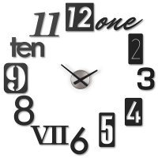
I go to bed in____________________________. | 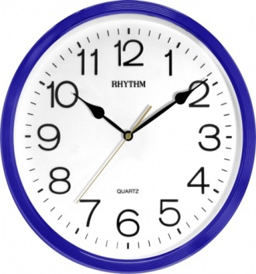
I go at school in_____________________________. | 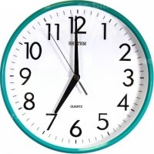

4. Запиши сокращённую форму порядковых числительных .
Первый
Второй
Третий
Четвёртый
Двадцать второй

5.Дополнительное задание.
Прочитай текст и ответь на вопрос.
New Year’s Eve
Nearly all adults in Britain stay up until midnight on the 31st
of December to celebrate the beginning of the New Year. In London’s Trafalgar Square, thousands of people gather to hear Big Ben chime. Then they all join hands and sing“Auld Lang Syne.”
It is a special celebration in Scotland, where it is called Hogmanay.
After midnight, people start visiting each other. The first person
to enter a house, The First Foot, is a very important person because
he is thought to bring good luck to the house for whole year. For
good luck. The First Foot must be a man, preferably tall and
dark-haired, and he must bring coal or wood for the fire, and
something to eat and drink. This means that the household will be
warm and have enough food and drink throughout the year.

- What is The First Foot?
- __________________________________________________________________________________________________________________________________________

