Внеклассное мероприятие: «Crosses and Zeroes»/ «Places to visit»

6 класс

«London. Places to visit»

Организационный момент. Приветствие.
Good morning, boys and girls! Today we have an unusual lesson. We will play the game “Crosses and zeroes”. Please divide into two groups, please, and choose the captains.
Now, when we have two groups, look at the blackboard. You see the table for our game. You will open one of the squares of the table and have the task to do. Each group will do the task and we will decide which group is the best and put the zero ore the cross into the square. At the end of our lesson we will count the crosses and zeroes and will name the winner of our game.
Ok, let’s start our game!

Игровое поле:
1  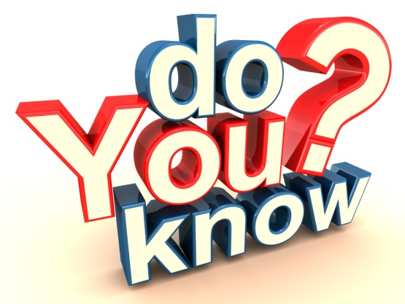 | 2  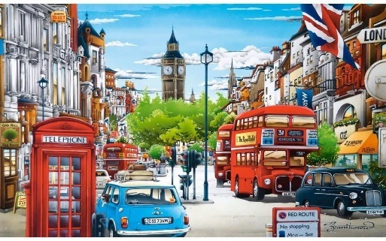 | 3  
4   | 5  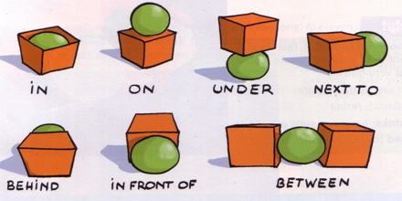 | 6  
7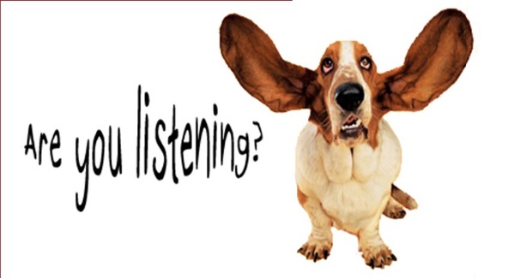 | 8 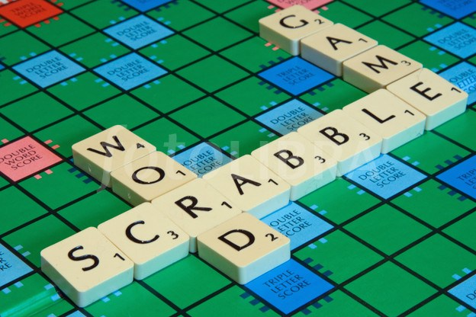 | 9 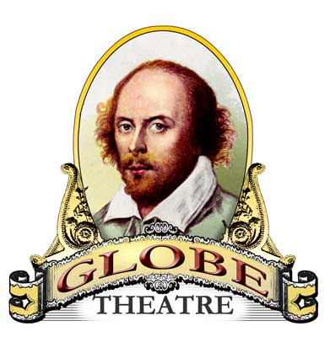

- Игра «Do you know?»

What is the capital of the UK? (London)

Who is Shakespeare? (a writer)

What is the name of the biggest clock in London? (BigBen)

What is the name of the British Queen? (Elizabeth II)

The symbol of England is … (a red rose)

What statue can you see in the middle of Trafalgar Square? (a statue of Lord Nelson)

What is the favourite hot drink in Britain?

What is the London Eye? (an observation wheel)

- «Sightseeing of London»
Look at the pictures, listen to me and answer what the name of the following places in London are.
- It’s a place where different meetings take place. In the middle of this square there is Nelson Column. (TrafalgarSquare)
- It’s the place where British kings and queens live when they are in London. When the Queen is inside you can see the flag over it. Important visitors often go to this place. They meet Queen Elizabeth and the royal family there. A lot of tourists go to visit this place. They stand outside and see the Changing of the Guard. (BuckinghamPalace)
- It’splacewhereyoucanbuyallkindsofpresentsandsouvenirs. (Covent Garden)
- It’s a place where you can see a lot of interesting things. There is a big dinosaur gallery there. (the Natural History Museum)
- It’s a famous departmentstore. It’s got 330 different departments.(Harrods)

True or false:
- Buckingham Palace is the official residence of the Queen.
- Big Ben is a beautiful London museum.
- Nelson’s column is situated on Trafalgar Square.
- The Tower of London used to be a palace, a fortress and a prison.
- Covent Garden is a famous department store.
- At the British museum you can see dinosaurs.
- Westminster Abbey is the river.
- Tower Bridge is across the Thames.

- «Matching»
What places of interest in London do you know? Match the two parts of word-expressions to get the names of the sights in London.

Covent | Ben
Buckingham | Square
Natural History | Garden
The Globe | Shakespeare’s theatre
Big | Museum
Trafalgar | Palace

- «Karaoke»
Командам предлагается исполнить под караоке песню на английском языке. Побеждает команда, которая исполнит песню дружно, громко и допустит меньше ошибок.

- Посмотреть на картинку и составить 5 предложений, используя предлоги.
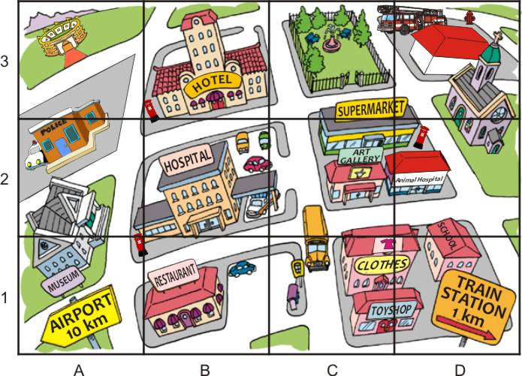
Example: The park is opposite the supermarket.

- The places to visit. Read and complete it.
(London, Trafalgar, Buckingham, galleries, Westminster, beautiful, city, are, museum, Big Ben, people)
… is the capital of Great Britain. It is one of … cities in the world. About 9 million … live there. It is a very old … . There … so much for people to see in London: parks, palaces, museums and art … .
In the centre of London you can see … Square. Not far from this square there is … palace. It’sQueen’shome.
… is the big clock tower. It’s a symbol of London.
There are many beautiful old churches in London: … Abbey, St. Paul’s Cathedral.

- Listening. You will hear students talking about London. As you listen them, complete the following sentences. The first letters of missing words will help you.
- London is beautiful. It’s d… from the other European capitals, isn’t it?
- Yes, I think London is one of the most interesting cities in the w… . There are lots of p… to see: famous m… , old cathedral, h… monuments and green parks.
- True! Yesterday I v… the Tower of London, saw the Houses of Parliament, h… the voice of Big Ben, and took photos od Westminster Abbey and Tower Bridge.
- Hundreds of t… go to Buckingham Palace to see the Changing of the Guard.

- Scrabble «Найди слова»
Командам предлагается словосочетание «PARLIAMENT SQUARE». За 3 минуты учащиеся в группах должны составить слова из данного словосочетания. Затем они по очереди называют свои слова. Каждое слово можно использовать только один раз. В финале побеждает та команда, которая назвала слово последней.
You should make as many words from this expression as possible. You have 3 minutes.
Then each team tells us their words in turn. The team who tells the last word is the winner.

- The Globe Theatre
Основные правила Игры КРОКОДИЛ.
1. Игроки команды имеют право отгадывать только слова, предназначенные для показа своей команде (свои слова).
2. Игрок показывает слова своей команде до тех пор, пока команда не сказали отгадываемое слово вслух или судья не остановил игру.
3. Если в отведённое для показа время никто так и не отгадал слова, игра останавливается по звуковому сигналу. Если слово отгадывается во время самого звукового сигнала, ответ засчитывается.

You should show the words with gestures for your own team only. You mustn’t say anything.
Ice cream
Elephant
Skate
Ride a bike
Shark
Owl
Gorilla
Play computer games
Go to bed

Рефлексия в конце мероприятия. Feelings and emotions

liked everything very much | 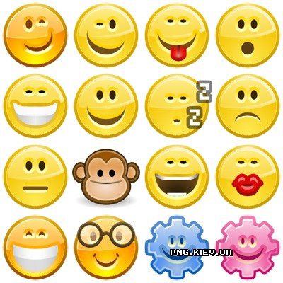
everything is OK
want to have more lessons like this
enjoyed myself during the lesson
didn’t understand some things

Жюри подводит итоги, считает количество крестиков и ноликов в игровом поле. Выигрывает команда, знаков которой больше, чем знаков команды соперника.
Well, children! We have the winners! The … (Zeroes or Crosses) have won our game! Well done!
And they receive the first prize!
Our lesson is over! Good bye, pupils! See you soon!

